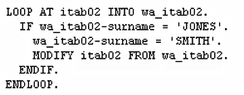

the modify statement again must reference the work area.

So, I'll bring in an example from using the header record, then we'll modify it, to use the work area.

So to summarize, we are telling the system to modify our Internal Table using the record we hold in our work area.